HORSERACING IS A DYING INDUSTRY BECAUSE IT IS NOT ECONOMICALLY VIABLE
38 AMERICAN RACETRACKS HAVE CLOSED IN THE LAST 20 YEARS.
26 of those 38 racetracks (68%) closed in just the last 10 years.
45% OF ALL HORSE RACETRACKS IN THE US HAVE FAILED and CLOSED.
CROWD ATTENDANCE AT RACETRACKS HAS DECLINED STEADILY FOR YEARS AND IS EXPECTED TO CONTINUE TO DECLINE.
For example, 80% of New Jersey’s $5.4 B in gambling revenue last year was online.
MAJOR HORSE RACES, such as the Breeder’s Cup and Kentucky Derby, HAVE SEEN SUCH A DRASTIC DECLINE IN VIEWERSHIP THAT THEY ARE IN DANGER OF LOSING NATIONAL TV COVERAGE.
GAMBLING ON HORSERACING IS IN DECLINE & EXPECTED TO CONTINUE TO DECLINE
The gambling market that horseracing serves is shrinking and is expected to continue to shrink. The younger generation “skill gamer” has many more options to bet on now that are more cost effective than horseracing and consequently, the younger generations’ portion of horseracing gambling revenue is experiencing negative growth. Studies predict that wagering on horseraces will be a mere fraction of what it is today within 20 years.
INCREASED COSTS TO THE EQUINE DIVISION OF GEORGIA’S DEPARTMENT OF AGRICULTURE (GDA) AND GEORGIA’S COUNTY GOVERNMENTS
The GDA Equine Division would be responsible for regulating a larger equine population when it is already underfunded and understaffed.
Historically, Georgia Equine Rescue League, LTD (GERL), a private non-profit group, provided vaccinations, hay, feed, castrations, fencing and shelter for all three facilities the GDA Equine Division used to house horses it impounded in cruelty cases since almost 1992, when Georgia passed the Humane Care for Equines Act without any appropriations. This past year GDA stopped impounding horses in cruelty cases and that responsibility now lies with local counties’ Animal Control agencies to impound, house and care for impounded horses. Many counties in Georgia do not even have animal shelters and of those that do, many can house dogs and cats but are not equipped to house horses.
HORSE OVERPOPULATION IS ONE OF THE INEVITABLE RESULTS OF HORSERACING & INCREASED BREEDING
The racing industry discards horses they cannot race or put out to stud, sticking the rest of taxpayers with the cost attached to caring for them for the remaining 80% of their lives. RACEHORSES’ LIVES ARE DEPRECIATED OVER 3 YEARS BY THE RACING INDUSTRY ON THEIR TAX RETURNS, (while a horse has a life span of somewhere between 25 and 30 years), allowing the racing industry to recoup their costs while they dump their unwanted horses onto the rest of the public to care for them the remainder of their lives. We already have an overpopulation of unwanted horses in Georgia and across the country, yet the racing industry continues to breed an additional 40,000 foals per year. There are not enough homes for those horses after racing and the horseracing industry has neither the desire nor the ability to care for them.
Slaughter has been and will remain, until the SAFE Act passes, Racing's "retirement" program. Approximately 65,000 horses are shipped to Mexico and Canada to be slaughtered annually. Slaughter is not euthanasia, but a brutal, long, and terrifying death.
HORSE FATALITIES and ILLEGAL DOPING = NEGATIVE NATIONAL PRESS & FEDERAL REGULATION
1,167 racehorses died on American racetracks in 2018, 1,104 in 2019, and over a thousand each year for many years. Thousands more are injured. They are over-raced, over-drugged and under-cared for. The doping and fatalities of American racehorses and the indictment of 37 major well-known trainers and veterinarians in the national news in March of 2020 brought renewed Congressional attention and new Federal regulation to American horseracing.

Horse fatalities at tracks have been putting public pressure on local governments to shut the tracks down, even tracks as historic and world renowned as Saratoga, Santa Anita, Hialeah, Belmont, and Churchill Downs. Protests against track fatalities are getting national press coverage at 26 different racetracks across the country.

These deaths and injuries are the result of too much strain being put on racehorses’ bodies. Some of the biggest prize purses are won in races held for two- and three-year-olds, which equates to placing a preschooler into pro athletics—they get hurt and their careers ended before they are even fully grown, when their skeletons are still hardening. The horse racing industry regularly uses drugs on horses meant to ease pain, such as morphine, to get them out onto the track again as fast as possible after injuries or strains. But masking the pain and running on existing injuries causes breakdowns or worsens the injuries. Racehorses have bled out through their noses and drowned in their own blood. They have snapped leg bones in training and races and are euthanized right there on the track. Ex-racehorses often suffer from months of drug withdrawal symptoms while being weaned off their racing medications (if they are lucky enough to not be forced to go directly to a slaughterhouse).
THE FEDERAL HORSERACING INTEGRITY AND SAFETY ACT OF 2020 (HIS ACT)
The federal government has streamlined and standardized with the HIS Act what was, in the past, 38 different sets of horseracing regulations across the U.S. that cheaters used to game the system.
The HIS Act was signed into law December 27, 2020. It imposes a ban on race-day doping, the establishment of a uniform national standard for rules and regulations for U.S. horseracing that would be overseen by the U.S. Anti-Doping Agency (USADA) under the FTC. The HIS Act requires a medication control program with better anti-doping measures and racetrack safety standards. Among the required elements of the horseracing safety program are sets of training and racing safety programs for injury and fatality analysis, investigation and disciplinary procedures, and an evaluation and accreditation program.
This increased regulation will inevitably increase overhead costs and reduce profitability of horseracing.
THE FEDERAL SAFE ACT WOULD MAKE SLAUGHTER AND TRANSPORTING FOR SLAUGHTER ILLEGAL IN THE U.S., increasing the number of homeless racehorses Georgia’s taxpayers will have to foot the bill for.
The Safeguard American Foods Exports Act or SAFE Act (H.R. 961 / S. 2006) will ban both slaughter and the transportation of horses for slaughter. It passed the House in 2020, died and could be re-introduced in 2021. Polls show 80% of Americans do not agree with slaughter.
GEORGIA DOES NOT HAVE A SUFFICIENT NUMBER OF EQUINE VETERINARIANS TO HANDLE AN INCREASE IN HORSE POPULATION
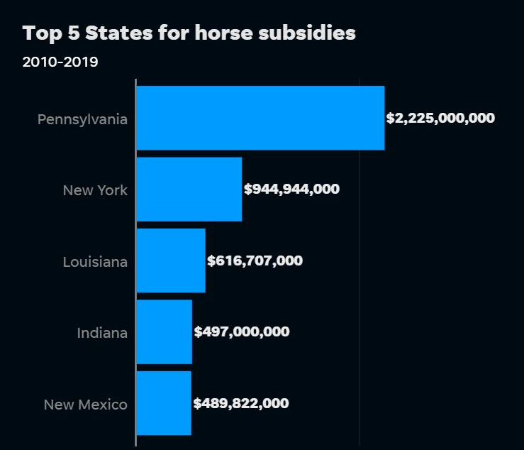
Georgia already has a shortage of veterinarians for large animal practices, as evidenced by the loan forgiveness program enacted by the legislature in 2016.
HORSERACING SUBSIDIES ACROSS THE U.S.
“Of 6,385 horses that died from 2010 through 2019 at tracks across the nation, 1,451 died during practice runs.
Although California and Kentucky do not subsidize race purses, prize money is up and so are horse deaths. Purses and other payments to breeders in California totaled $153 million in fiscal year 2017-2018, up $10 million from the previous year. Kentucky added nearly $14 million to race purses over the last year, boosting total purses by 48 percent in one year. California's horse deaths rose from 74 in 2014 to 115 in 2018. There were 18 race and training-related deaths logged by the Kentucky Horse

Racing Commission in 2014, which rose to 67 in 2018.
States that inflate purses with casino money see more horse deaths on average per 1,000 starts. States that subsidize averaged 2.32 deaths per 1,000 race starts from 2014 through 2018. States that do not provide subsidy money averaged 2.19 deaths during the same time.
Pennsylvania leads the nation in racehorse subsidies ($240 million per year) and total horse deaths (556) from 2014 through 2018. Pennsylvania, with its three thoroughbred racetracks, subsidized no less than $228 million per year to the racing industry, or a total of $2.2 billion since 2010, the year the Network began tracking the subsides. The state's 2018 subsidy is $242 million, up $3 million from the prior year. Pennsylvania's decade-long support is followed closely by New York, since 2010, with $944 million, Louisiana with $616 million, Indiana with $497 million and New Mexico with $489 rounding out the top five subsidized state.” – USA Today 10/31/2019

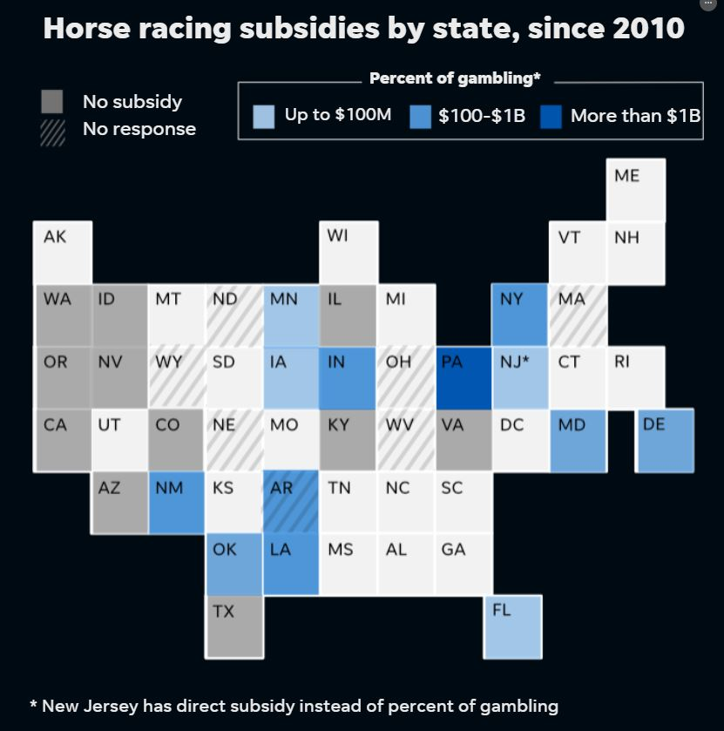

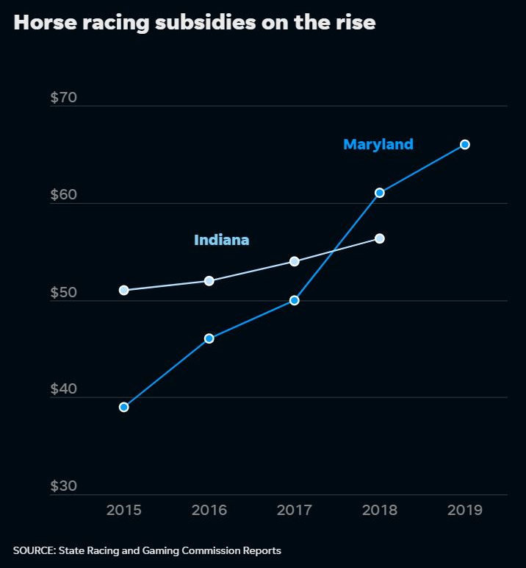

https://horseracingwrongs.org/
https://www.reviewjournal.com/sports/betting/nevadas-horse-racing-handle-in-sharp-decline-before-doping-scheme-1976742/
https://www.thoroughbreddailynews.com/this-time-horse-racings-aging-demographic-problem-is-very-real/
https://eu.usatoday.com/story/sports/horseracing/2019/10/31/breeders-cup-horses-go-racetracks-slaughterhouses/2485345001/
https://www.horsenation.com/2020/02/13/equine-slaughter-fact-check/
https://www.businesstimes.com.sg/life-culture/horse-deaths-are-threatening-the-racing-industry-in-the-us-is-the-sport-obsolete
https://horseracingwrongs.org/
https://www.theguardian.com/sport/2019/aug/02/the-sport-is-at-a-tipping-point-inside-us-horse-racings-deadly-crisis
https://www.congress.gov/bill/116th-congress/house-bill/1754#:~:text=Horseracing%20Integrity%20and%20Safety%20Act%20of%202020.%20This,on%20the%20development%20and%20maintenance%20of%20the%20programs.
https://www.aspca.org/about-us/press-releases/aspca-research-confirms-americans-strongly-oppose-slaughter-horses-human

